BEDFORD – Construction of MassDOT Maintenance Facility
on Route 62(Burlington Road)

General Overview and Scope of Work

The proposed project consists of replacing the existing Bedford maintenance depot site located upon 4.46 acres on Crosby road in the town of Bedford with a new facility located on Route 62 (Burlington Road) in the northwest quadrant of the Route 3 /Route 62 interchange.

The proposed facility will replace two old salt barns and a construction trailer with a gambrel style salt storage barn, a metal maintenance building, two above-ground liquid deicer tanks, an access drive and plow/spreader staging area, and parking for MassDOT personnel. The existing site is being sold as surplus to provide the opportunity for expansion for local business.

The proposed salt barn will be capable of storing over 5000 tons of salt and will permit indoor loading of salt during winter snow and ice operations. The maintenance office and garage will provide an efficient work area and covered space to store work vehicles and equipment. Work will also include excavation and paving, lighting, landscaping, fencing and stormwater controls.

This project will provide MassDOT –Highway Division with new more efficient facility with better access to Route 3 while returning 4.46 acres of developable land to the town of Bedford’s tax base.

Project Location and Existing Conditions

The proposed 5.65 acre site is located in the northwest quadrant of the Route 3 and Route 62 interchange and is west of the existing depot across Route 3. The site fronts onto Route 62 (Burlington Road,)
acres and is comprised of wooded upland with exposed ledge outcroppings in many areas which will help screen the facility from view.

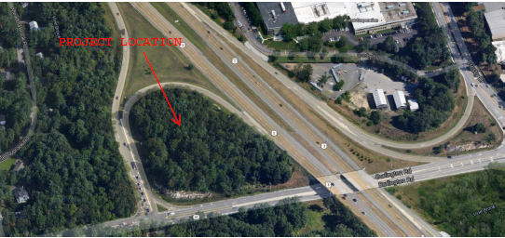

Project Location Aerial View
LOCATION MAP
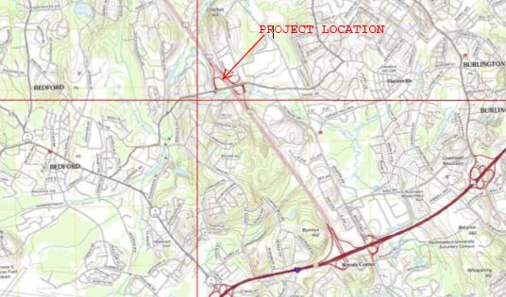

Utilities
It is anticipated that one utility pole must be relocated and wires raised to provide access to the proposed site. In addition, Tie-ins to existing water, sewer gas and electric utilities must be made to service the proposed site.

Right of Way
The project site falls entirely within the loop ramp of Route 62 and Route 3 upon land owned by the Commonwealth. No right of way acquisition or easements are anticipated for this proposed work.

Project Cost
This project was approved by the Massachusetts Department of Transportation for
Non-Federal Aid(State) funding. The total project construction value stands at $5.2 million which will be funded in part from the $4.3million gained from the anticipated sale of the existing site.

Project Status
The plans are at the 25% Submittal Stage. Comments received will be considered in determining the final design. The construction is anticipated to be completed within one year of award. The project is currently programmed for Fiscal Year 2015.

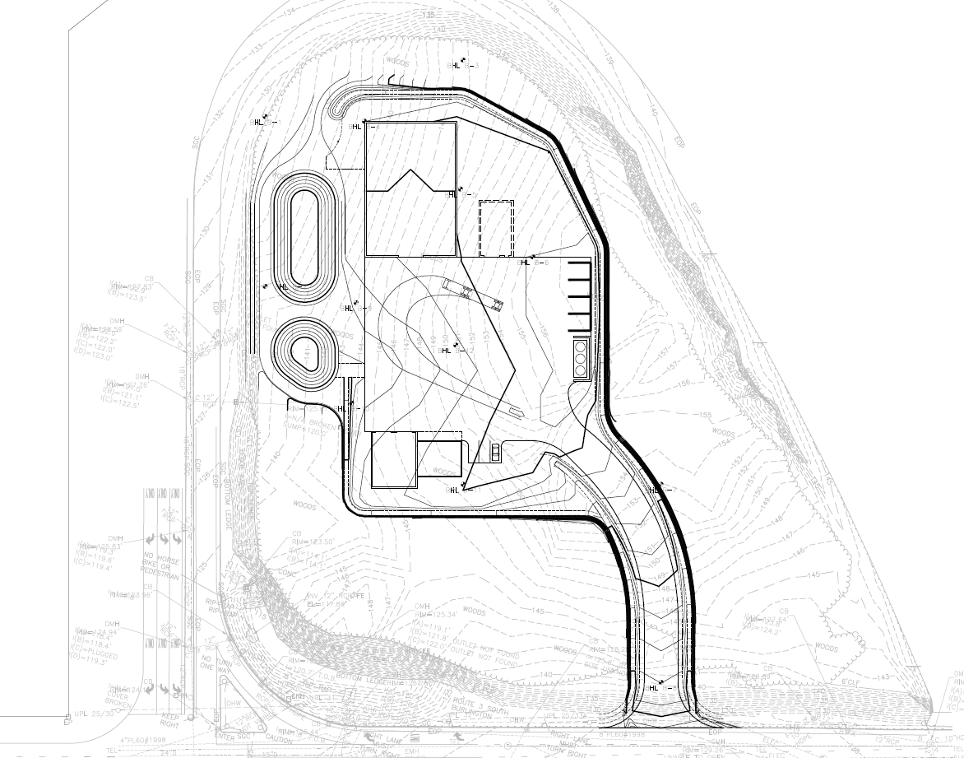

Concept Plan of Proposed Facility on Route 62(Burlington Road)

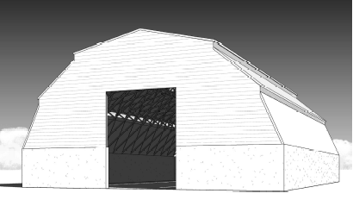
Rendering of proposed Salt Barn

